"who are you, little i
(five or six year years old"
peering from some high

window; at the gold

of november sunset

(and feeling that if day
has to become night

this is a beautiful way)"

e. e. cummings

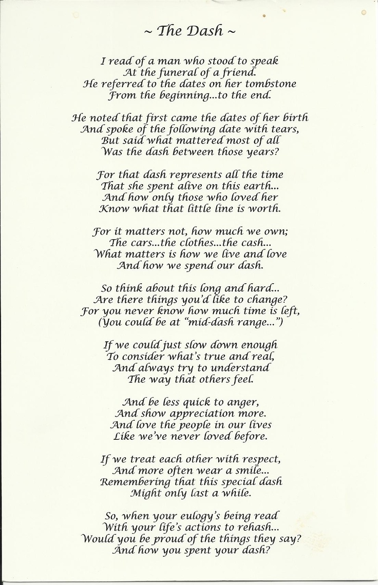
Who are you little i
Catholic, Episcopalian, kind
A white man who wishes he could erase the pain that color has caused
One of seven (on paper) but it feels more like 2 or 3
Father, husband, humbled by these roles
A voter who has grown weary of ‘gotcha’ politicians
A man who has a comfortable life; yet still fearful of the poverty known in youth
Who are you little i
Teacher, writer, runner
Listener, watcher, waiter
Wondering who I am and how I came to be who…this who

