You’ll Never Know
1975. I am six years old and I am riding with my dad in his Buick Skylark. Maybe it’s a Chevy Malibu. Whatever the car, it’s the size of a small tank with an endless front hood, Batman-like tail lights, and bench seats that are equal parts cushion and spring, and 100% bounce.
It is a moment that is forever etched in my mind.
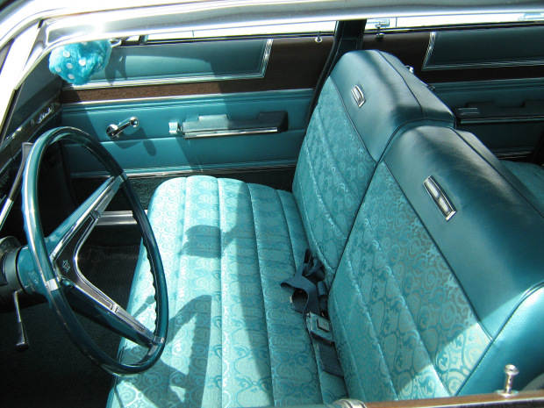 My dad and I are riding in the car. It is a Saturday morning. I know this because the mood is light–the weekend is here and the day holds much promise and possibility. It is summer because I am wearing shorts and the windows are cranked all the way down. I don’t remember where we are headed. I don’t care. I am riding with my dad–alone. ALONE. Not one of my 6 brothers and sisters to bother me. No one to share the front seat with. Yes, the front seat. I sit across from my dad in the front seat, my legs dangling over the edge of the embroidered nylon bench. No seat belt to trap me in. Just me and my dad cruising on a weekend morning.
The car glides around a bend and I fly across the seat, toward him. I stay there. My bony leg next to his. My elbow resting on his lap. I watch his hand dance along the steering wheel, a cigarette dangling from his lips. He’s so cool. He’s my dad.
As I bask in this time alone, he starts to sing:
You’ll never know just how much I miss you
You’ll never know just how much I care
And if I tried, I still couldn’t hide my love for you
You ought to know, for haven’t I told you so–a million or more times
You went away and my heart went with you
I speak your name in my every prayer
If there is some other way, to prove that I love you, I swear I don’t know how
You’ll never know if you don’t know now

I am awestruck. “Again!” I cry. “Sing it again!”
He protests, realizing he is vulnerable now.
“Please?” I beg.
He obliges. You’ll never know…
We drive on. A dad serenading his son. I feel like the most important kid in the universe.
**********************
For a while after that, on the rare occasions when my dad and I would be driving alone, I would ask him to sing that song. It turned into our little duet, as I would echo the last part of each line.HOW MUCH I CARE…MY EVERY PRAYER. It always made me happy, and could serve to draw him out of a mood if he was a little brooding that day.
And then, like too many things in childhood, it just stopped. One day, I stopped asking and he stopped feeling comfortable singing it to me. There were many times when we would be driving in the awkward silence of my teenage years, where I would think about that song, where I would wonder what would happen if I requested it, where I would laugh in my mind at the absurdity of my dad singing to his son, now almost an adult. I never asked, though, and as the song implies, now I’ll never know.
**********************
About nine years ago, I heard that song in, of all places, Disney World–the happiest place on Earth. The land of make believe? I was walking down Main Street by myself. It was nighttime and the crowd was thin. I had never heard the song performed by anyone but my dad, yet here I was, being serenaded by the lilting voice of Alice Faye–I checked. My dad had long since passed away, and now I had an infant of my own. I looked up in the night’s sky from the streets of the Magic Kingdom. You went away and my heart went with you…
Yes, a piece of it did. But larger pieces remain behind. Embedded in my first-born son, and soon thereafter, his brother. There are many car rides for us now–smoke free with them tethered safely in the back seat. But I try to remember the glory that can transpire between a father and his son in the more subtle moments of life, on an insignificant car ride, on a random weekend morning.
Car rides that may, in fact, last a lifetime.

Caution: Lifeguard on Duty Will break Your Heart
It is the summer of 1977. Our nation has finally recovered from all of the hullabaloo surrounding The Bicentennial. Disco Fever will soon take to the dance floor as everyone tries to imitate John Travolta‘s finger pointing. And WiFi 92 FM still can’t get enough of Paul McCartney and The Wings singing about “Silly Love Songs“: You’d think that people would have had enough of silly love songs…But I look around me and I see it isn’t so…
I find this song rather fitting because, you see, I am in love. Yes, I am eight years old, and I have fallen in love. Her name is Lynn. She is sweet, pretty and kind. Her brown, shoulder-length curls are sun-kissed with streaks of blonde; her long limbs are the color of caramel; her smile, electric. Lynn is probably around twenty, but age does not matter. I love her, and that’s all there is to it.
I met Lynn at our swim club, Sunny Willow. She is a lifeguard there. I watch her sit atop the chair, ready to risk her life to save another’s. Occasionally, I get up the nerve to smile at her when I walk by her as she switches from guarding the shallow end to the deep end. I may even say “Hi” to her when I am coming back from the snack bar with two fistfuls of Swedish Fish–a penny each, and I buy a dollars worth. Her smile back gives me hope–she looks like the kind of woman who would wait–if the right boy comes along.
********************
“Michael, you have to take swim lessons this summer.” My mother announces this as we are driving to the pool in our purple station wagon.
“No way! I can swim.”
“Well, you need to get better. I’m signing you up,” she insists.
I feel a nervous pang in the pit of my stomach. I still associate swim lessons with my horrible incident at the local high school–the one where I went to the bathroom in the pool. (Read about that here). I’ve all but put it out of my memory. I try to relax. After all, I am older and wiser–and in love. Then, I have an epiphany: maybe I will have Lynn as my instructor!
“Okay, sign me up!”
***************************
The list is posted on the bulletin board by the showers. The gods look upon me favorably–Poseidon…Neptune…they’ve felt the pangs of love that I now feel. They know what it’s like to be under a siren’s spell. I see my name on the list, and above it my instructor’s: L-Y-N-N.
For two weeks, I float on air. I jump from my trundle bed and eat my Alpha-Bits with my bathing suit on, anxiously awaiting to be driven to the pool. I spend every weekday morning with Lynn. For forty-five minutes she and I (okay, and about 6 other kids) swim together in the cool morning breeze.
Some people wanna fill the world with silly love songs.
And what’s wrong with that?
I’d like to know, ’cause here I go again
I hum the tune and repeat the lyrics in my mind, as I wait at the water’s edge for Lynn to take my arms and bring me out to examine my technique. I lay on my back in the water and feel Lynn’s hands supporting my head. “Kick,” she commands. And I obey. I kick with all my might. I look up at the blue sky, and feel as if I am already in heaven. I wish this moment could last forever. “Good job,” she says, releasing my head, and I swim back to the others, beaming with pride.
I love you, I love you,
I love you, I love you…and I do. I’m not sure what it all means, but I feel the fire in my stomach; I feel my heart beat faster when she is near. And as a result, I want so badly to impress her. To awe her. Maybe it’s foolish to think she can love a scrawny eight year-old, but perhaps she will fall in love with my form. So I swim with all the bravado that my chicken legs can muster, I splash my tiny arms with the might of ten Olympians. Lynn praises me–well, all of us. She smiles, and nods, and says how well we are all doing. And after lessons, I get to hang around the pool all day. I practice the movements as she explained them, and I do so in earnest, hoping she will notice me as she tends to her other life-gaurding duties.
I can’t explain the feeling’s plain to me, say can’t you see?
Ah, she gave me more, she gave it all to me
Now can’t you see,
The weeks go by too quickly, and before I know it, our last lesson has arrived. It is bittersweet. My time with Lynn will be less, but I feel I have greatly improved as a swimmer, and no one can take away this bond we have formed. As I enter the gate for our final class, I run immediately into her: my instructor, my muse.
“Hi, Michael!”
“Hi,” I say, sheepishly.
“I’m glad to see you. I wanted to talk to you about something before our last lesson.”
“Sure,” I say. An award, I think. I’m getting an award! I have impressed Lynn so much that she wants to reward my efforts. This is the beginning of our future together. We will open a swimming school and spend our summers training kids–underprivileged kids– to be as skilled as we are.
“Why don’t we sit over here?” she asks.
We approach a picnic table and sit across from one another. Her eyes look especially green against the painted tabletop. Her white teeth dazzle me. An award! In my mind, I try to think of the title for my award: Most Improved…no…Fastest Swimmer…no… Most Likely to make the Olympics…I have a dazed smile on my face, but Lynn’s face does not mirror mine. She is not smiling. In fact, she seems to be frowning. I begin to tune in to her words: “I’m sorry, but you’re going to have to repeat the lessons. I cannot pass you this time. You’re just not ready.” I say nothing, just nod slowly. “Okay?” she says, tilting her head. “Um-hmm,” I lie. I am not okay. A minute ago I was captain of the swim team, standing on my diving block waiting to take the gold. Now, I am a dejected loser.
Lynn and I get up from the table and make our way to the pool. She puts her arm on my shoulder, but inside I recoil. It’s too late. I cannot bear her touch now. I am nothing but a disappointment to her. I spend our final class together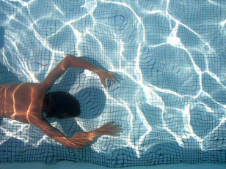 sulking. My movements are sluggish, slow. Every splash of water laughs at me mockingly. My heart is too heavy to swim, to float. The woman I love does not love me back–cannot love me back. She cannot even find it in her heart to pass me in swim class.
Love doesn’t come in a minute,
sometimes it doesn’t come at all
I only know that when I’m in it
It isn’t silly, no, it isn’t silly,
love isn’t silly at all.

